Count Your Blessings in the Storm
June 21, 2017
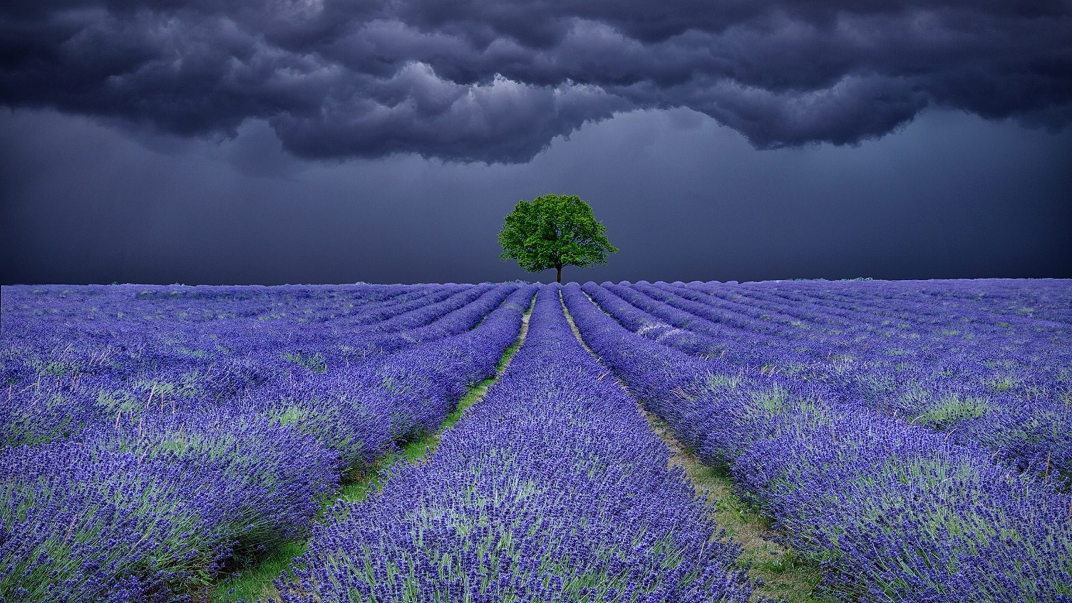
Lord, no matter what the storm is, or heat we are feeling, please help us to always be so grateful for Your many blessings and graces.

This week I have been given some amazing gifts…yet the storm continues in one form or another. And I realized I had been short on thanksgiving and long on complaining. It is summertime after all, and when it’s hot, tempers tend to flare. And I thank the Lord for reminding me to stay in a grateful place, because things could be much worse.

Very uncharacteristically I heard, “They signed up on this outfit, there are going to be continuing challenges.”

Doesn't sound like the Lord...

Normally that’s not the phrasing Jesus would use…but in this case I think it was me interpreting what He was saying, and just musing on it in a rather rough, Southwestern way.

So, when He really did begin to speak, I heard, “But yes, you all should count your blessings. You tend to forget your gifts and victories after the battle. They have become yours to use now, and you don’t remember what it was like before the battle and before you had the gifts. So, you forget to count your blessings.

"You remember the battles and the pain, but forget all that was accomplished and that you are now living in abundance in different areas because of it. It is human nature to take victories for granted and shelve them, not realizing what richness they brought to the life you are now living because of them.

"Therefore, it is good to stop and count your blessings compared to where you were at 2 years ago when you first began this journey on this channel. For instance, you are now more skilled in warfare. That also means I can send you into more battles. You can free others as well as yourself. You understand My ways much better, so when difficulties arise you know it is not a punishment but a challenge with many rewards, once completed.

"Many of you were content with life on the hillside, yet something inside of you longed for more of Me, and more meaning to your lives. Because of this, I can now raise you up into the higher places where the winds are more fierce, the climb is steeper and the opportunities for rest are fewer and fewer. At the same time, the view is glorious. You can look down the mountainside to the valleys and the dales, where hand-to-hand combat is taking place. Yet, in these high places there are beasts you will encounter and have the victory over.

"There are so many benefits to continuing on the climb— they outweigh the deficits. You are over and over again being formed into My image and likeness as you shoulder your cross and prepare yourselves for the next climb. There is no time to tarry in this high places. Your time is more valuable than it has ever been and you are touching more souls than you ever have in your lives. And many of you come with Me at night while your body rests and are given even more opportunities for ministry and even learning.

"Yes, you are truly a soldier in My army. Special forces being prepared for the out-of-the-way extraordinary assignments. And yet, you are daily learning to die to yourself and live as the lowliest in My Kingdom, which means you will often be called to menial tasks others disdain. But for you they are advanced courses in My university of life, and as you go lower and lower in your attitude of service, I can raise you up into positions of more authority and responsibility and you will not abuse your status in Me. Rather, you will walk humbly before Me and all men.

"Yes, this outfit you signed up for gets into some very tough territory, and it seems that the challenges never end. There never seems to be a vacation—but just one more battle to deal with just when you were ready to rest after the last battle. I am building up your stamina, and in this, preparing you for even higher places with more ferocious winds, rock slides and predators. The fare here is not rich but barely sustains you as you go from one level to the next.

"Count your blessings, that you are truly taking rough terrain from the enemy, learning more skills, winning more battles and even getting the spoils. You are seeing major prayers answered in your families. You are seeing provision, anointing and the sweetest of all: communion with Me as we linger together as one. That truly is the choice prize. Yes, the wonderful one-on-One relationship you have with Me, My Bride. This is yet another gift and source of great strength.

"You see there are storms and rainbows, and I bring you through both, helping to fortify and make you stronger and wiser. You have seen many treacheries from the enemy in your lives. You have encountered pits that were dug for you, deceitful circumstances that looked different from what they actually were. You have followed and made decisions based on some of these and now are being restored much the wiser for all you suffered.

"So, My Brides, yes. I want you to rejoice in your victories, but know that the battle is not over yet until I remove you in the Rapture. And then you will have new and glorious assignments you never even dreamt of.

"But here I am asking you to pause for a moment and count your blessings. Look at the things that were not in your life before, but they are great victories and something to celebrate as they are implemented and you move forward.

"Look also at how your character has changed and you more resemble Me than ever before. Look at the peace you feel in difficulties, because you KNOW I have an important purpose for them and I will in the end deliver you. I am with you. Steady as you go. I am helping you climb and even recover simultaneously as you rest in My arms."

